project: hexagon-part a

Index:

|  |  |  |
| --- | --- | --- |
| **Serial number** | **Topic** | **Page number** |
| **1** | Introduction to hexagon | Page no  2-3 |
| **2** | Objective | Page no-4 |
| **3** | Parts of hexagon and their ability | Page no  5-21 |

Part B-numerical calculation of the path for the lunar orbit

Part C-frame integrity

Part D-life support system

By: Tejas.s.koundinya email:tejassurajkoundinya@gmail.com

Contact number: 9113094822 / 9019476699

Address: Garudadri Lavender, Survey number, 14/1, 60 Feet Road, Kanakapura Rd, Judicial Layout 2nd Phase, Talaghattapura, Bengaluru, Karnataka 560062.

## inroduction to hexagon

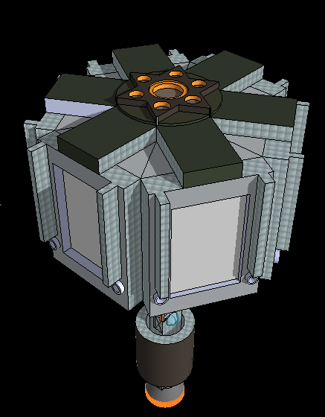

Hexagon is a special sat developed to create an artificial lunar base, which helps us to study the moon surface in a simpler manner which also helps to further development for humankind to start surviving on the lunar surface. There are 2 major execution process known by red and green which is explained later. This project can not only be used for our studies even can be used to get back a part of our finances which are used over its development, hence making the project cost effective.

This program is to ensure the development of lunar base and gather resources from the lunar surface and bring it back to earth with high integrated launch vehicles attached to the rovers and with design of high launch capsule from the rover or the controller.

This helps us to have a superior advantage of transportation of space valuables in the easiest way possible from the lunar surface to earth. This resource also helps us to understand the lunar surface and helps us set an example for the world.

This project is designed for multi task effect only by single modulation we can archive a huge number of task the chambers are designed to help the source to carry both cargo and life stock hence allowing it to reach its maximum effect on a small scale.

This project will also be one of its only kinds as it will be under development with an optimum laser communication system and can also be replaced with an antenna system if required. The program will help us to understand and transferring of data in a very productive manner ever seen in human kind hence helps us for high-end tech development of our nation and making it the only country having a communication system so advanced.

Apart this the most important feature is this program helps us to launch min sat after development into the lunar orbit in a much more less cost hence leading us to have a one and only kind launch system in place. And also the rover’s capability helps to run on missions for a longer time due to min rover system which is an integral part of the program hence allowing us to experiment on mini-prototypes in a very effective manner and this helps us to have a wider range search.

# objective of the mission

1. ***To have a lunar base fully operational***
2. ***Search the maximum area for RD***
3. ***Have a fast and effective data collection***
4. ***Gather resources for RD***
5. ***Getting back collected samples with ease***
6. ***Have a launch site on the lunar surface***
7. ***To ensure in future, lunar missions will be cost effective***
8. ***Use the resources gather to make valuable development***
9. ***Obtain a well established network over the lunar surface***
10. ***To cover the cost of the mission as low as possible***
11. ***To acquire data and process them at optimum speed***

## Parts of HEXAGON:

1. Controller
2. Chambers
3. Rovers
4. Sat1

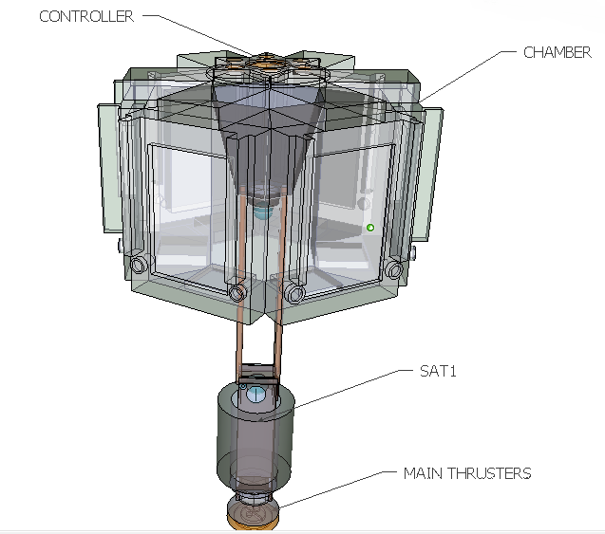

# Part 1. Controller green/red

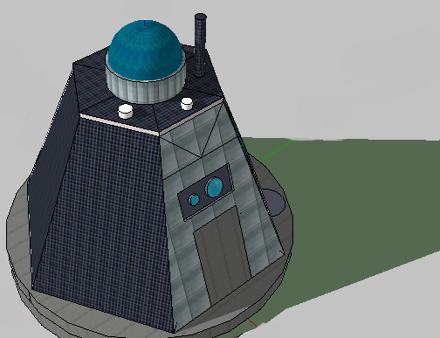

Controller is a main part for the program. This program can be set up for 2 actions one is for the astronauts and the next is fixed communication for chambers and rovers on the lunar surface. The controller also plays the role of bringing back the astronauts from lunar surface /moon surface .The controller is designed to adopt to both the communication methods as listed below the port can play only one role at a time as a moon communication system or a port to bring back the astronauts ,communication system of the controller are:

* leaser communication
* wave communication(antenna)

Note: controller is only for survivor basis or else, if we do not want men in the mission the controller then it is replaced by the Controller *red which* will be controlled by the controller base from earth all the instructions will be passed by the controller to rover hence controller is non life supporting controller in hexagon which is replaced by controller *green*

### Frame designs for controller

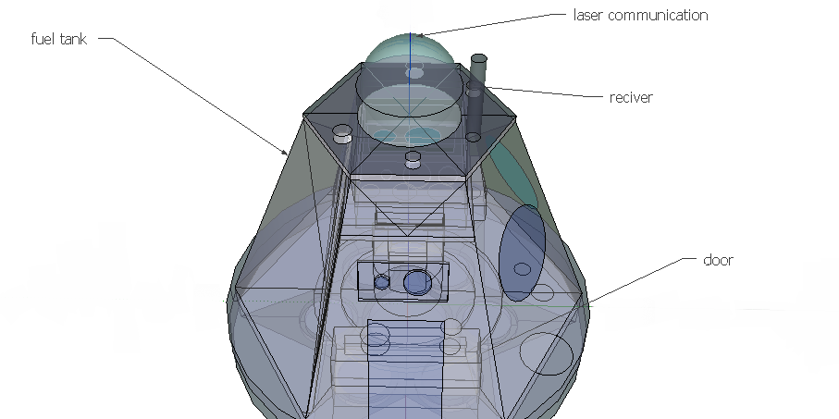**GREEN/RED BASIC STRUCTURES**

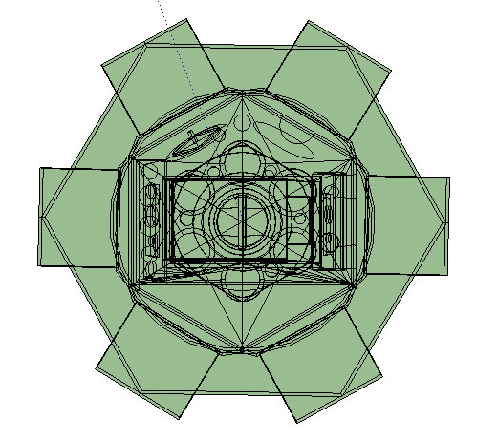**Top view**

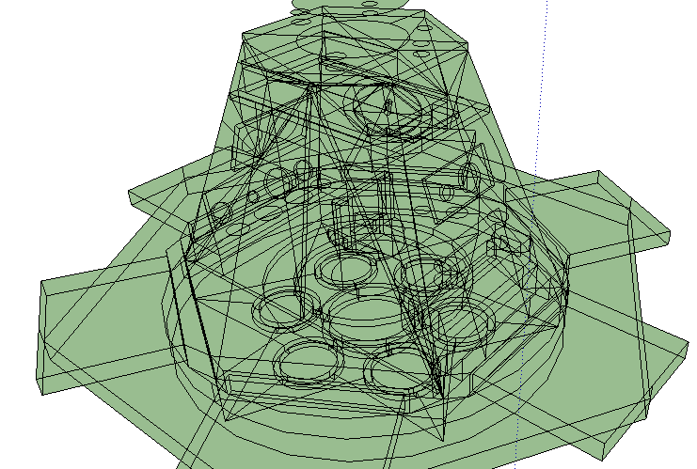**Side view**

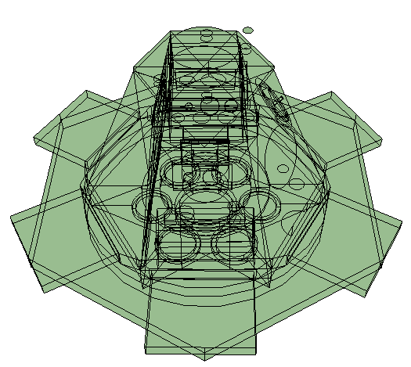**Front**

### Internal structure of the CONTROLLER (green)

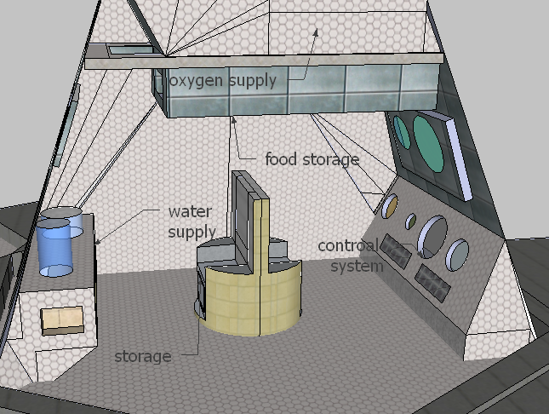

### Internal structure of the CONTROLLER (REd)

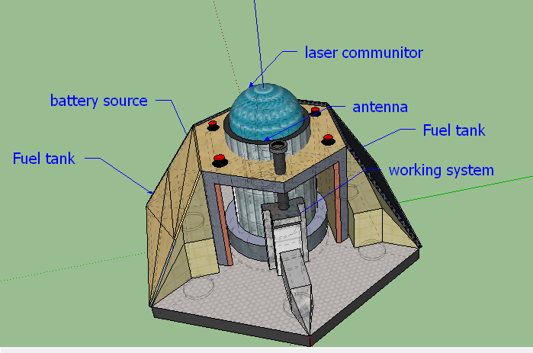

The above two system are for 2 different ways having their advancement

Project green is designed to carry astronauts to the moon and must be integrated with special system for takeoff and landing capacity this would not be needed in the red mission as it will not be taking any astronauts into space hence we would need a command station which helps us to communicate with the rover from the controller.

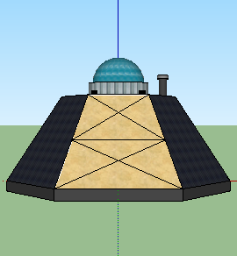

### support system for astronaut in hexagon

|  |
| --- |
| Basic needs for astronaut and the controler |
| 1. O2 supply. |
| 1. Water system and drain system. |
| 1. Main system. |
| 1. Fuel tank. |
| 1. Communication |

### O2 supply system water & drain system

Hexagon is having multiple ways of producing o2 but in the controller it is designed to hold o2 tanks to make the astronauts trip only at the time on their journey to moon as they reach the moon surface the astronauts switch to the astronauts lunar suit then they turn off the o2 supply on the controller and they are running on o2 supply on their suits then the rest of the o2 in the controller will be used for the rest of the journey back to earth from moon.”The chambers will contain water storage which will be electrolyzed where H2O separates to hydrogen gas and O2 gas the H2 is moved for storage in chambers and to refill the controller hence giving the astronauts more time to gather samples from the moon surface”.

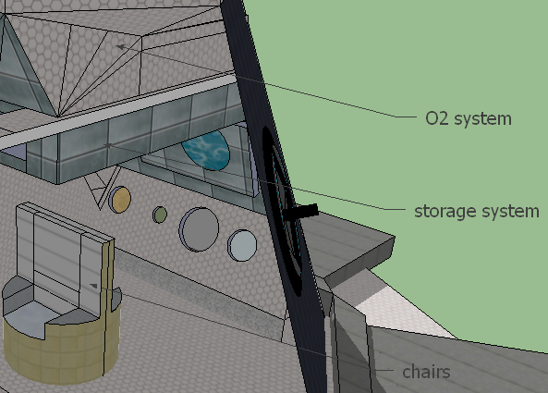

The extended storage system is used for additional system development and allows us to bring back resources from the lunar surface and helps us to attain extended system development and which plays a major role in keeping the operating system on-line hence helps us to get easy access to all essentials when required. Chairs are built to provide effective drain system inbuilt with them the drain is stored and can be used for development in the lunar surface for habitat survival and is effectively used in new water development within the controller and can help us for a full [water drain system](photo%20of%20HEX/water%20system.png) which is interlinked for optimum efficiency. The system is shown below in main system.

### Main system

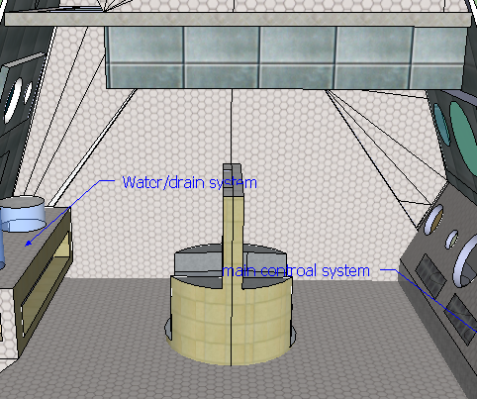

The above system is designed to operate in effective manner and the chair pattern can be adjusted as per the users and the system with it can also be changed. The main control system and water /drain system are done by modulation and the storage unites can be extended for better development of the controller system and the storage is also provided below the chair. These help the astronauts for maximum optimization

The system inside is done with [frame work](photo%20of%20HEX/frame%20side%20view.png) of titanium helps for the structural integrity of the controller.

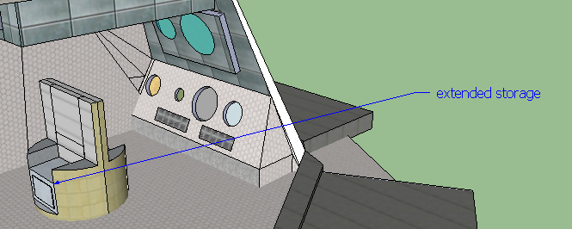

The extended storage system for any upgrading and others.

## Battery system for hexagon RED is as mentione bellow:

The system is designed for both abilities to support life or for integrated communication system supported by battery system / energy system which is integrated with the solar panel on the controller which supports the 2 batteries built for support channel of the controller. The 2 batteries are for long duration made of 12Mw hence helping us for a long time but the inner system has been developed to modify also to fit in a [reactor core](photo%20of%20HEX/reactor%20core.png) if necessary only.

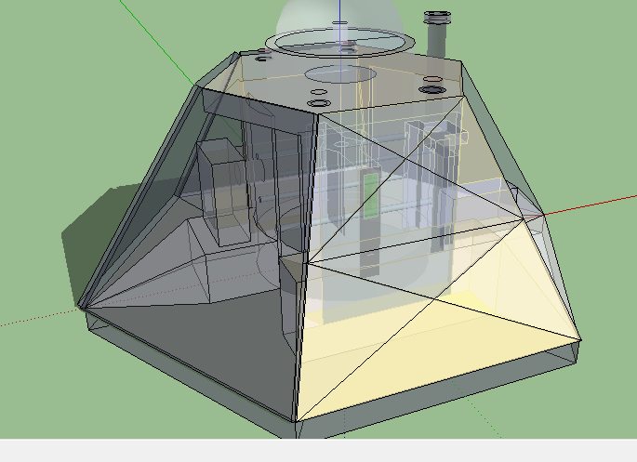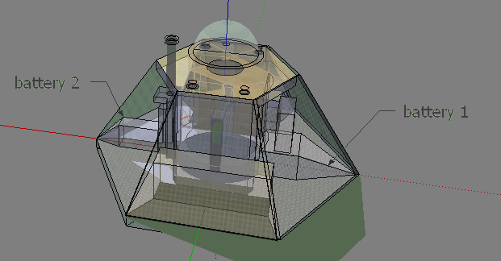

The battery system is integrated to all solar panel and hence helps us to recharge the battery. The reactor is within a power potential of 15mW and hence help us to develop a full efficiency system which would run for a very long time. The solar panels are planned to pop out of the shell once landed and helps to acquire full efficiency of the solar light.

## Battery system for hexagon GREEn is as mentioned bellow:

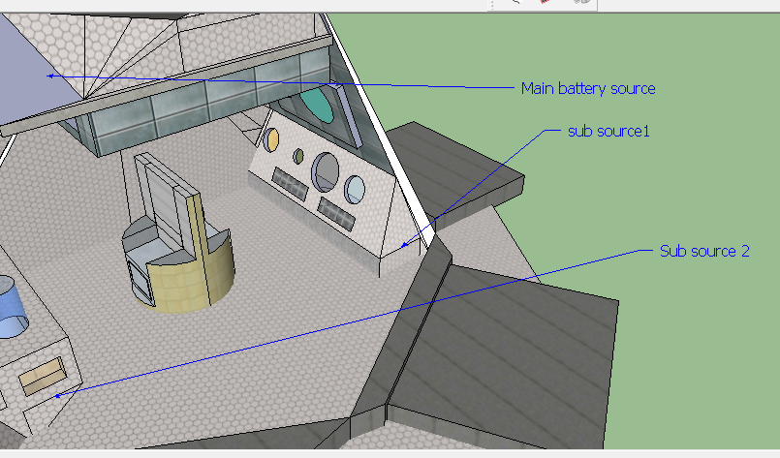

This is much simpler system which does not have any reactor core acting on it hence just a simple solar panel to battery having a simple source of 12Mw as the mission of green is just for a few months hence it helps the system decompression is 20% per full charge hence they will be the best way of approach for such a small time.

This system for command center on lunar base for a temporary time is the best line of approach to be within this time duration.

The battery system is interlinked to the chambers hence having more efficiency in recharging the internal chambers and the controller this helps the astronauts to run on a 60% battery capability running in the background.

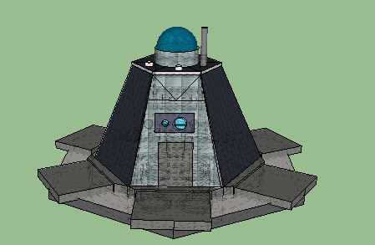

### Fuel TANK & THRUSTERS

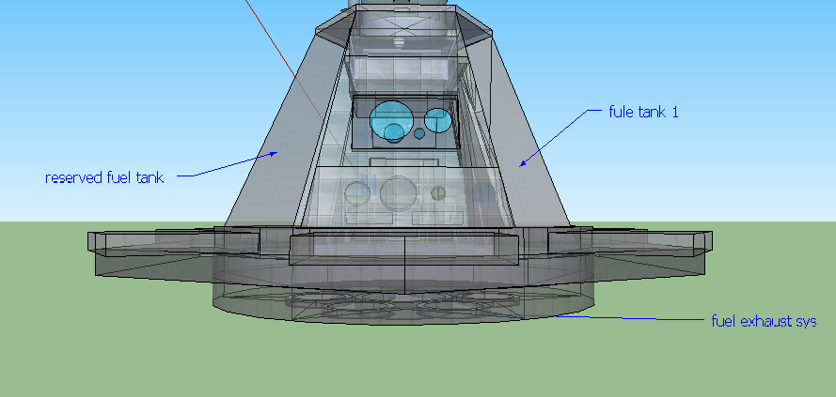

The fuel system is developed for advance mission development in other terms the fuel tank 1 is the main source of fuel but the reserved fuel tank is just for other missions which would require high fuel for takeoff from the surface.

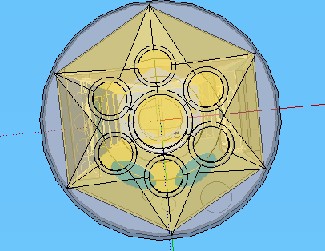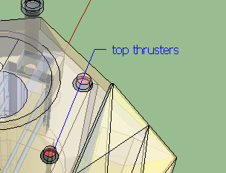

There are 7 thrusters straight off lift and land back capability on earth surface and 4 top thrusters and 12 side thrusters 2 on each side to maintain structural integrity.

### The ways of communication and their CHALLENGES:

* The antenna is used only for moon surface com with the rover only for short distance the pole is designed to elevate above and which allows it to send signals to the rovers the receiver receives signals and send the data to the sat1.”The laser com can be replaced with a receiver and antenna as due to lack of information and resources on the laser technology we can let the laser com down”.
* Laser com is good for long distance com and is much faster then compared to wave communication only few companies are successfully completed the laser com such as:

1. *EDRS European data relay system (is operational).*
2. *LASER LIGHT COMMUNICATION (in development).*
3. *GOOGLE LOON (in development).*
4. *SPACE X STARLINE (in development).*

* As we see there are only few systems that have made a success story but most are still being developed this system hence hexagon may have few factors which are ahead of its time for such a range.
* we can use umbrella antenna to be placed instead of the laser com system it can be adjusted in-between the sat1 and controller

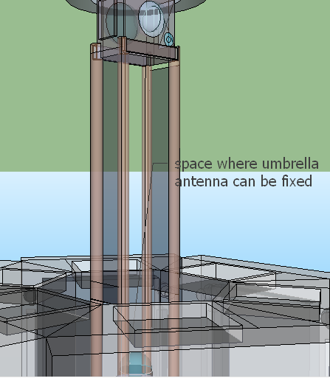

* This is not the first time we are using an umbrella antenna on a sat this technology is well developed and is in current use by nasa and spacex.

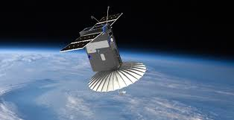

* As we install the umbrella antenna to the controller to should be designed to be doing both task for receiving and transmitting signals.
* This is the extended design for the controller with the joints 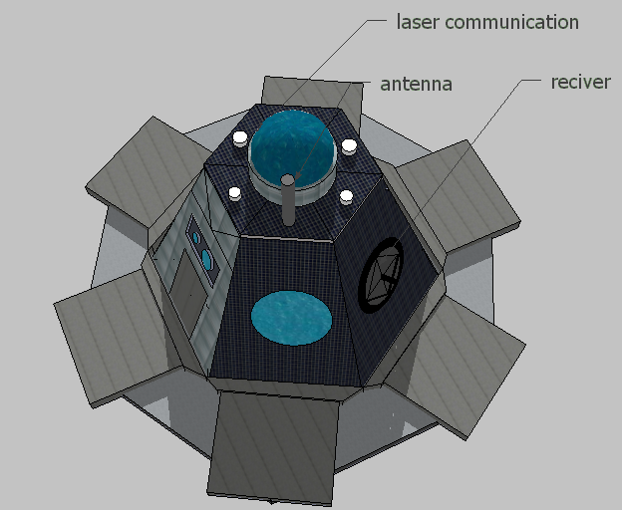 the extended parts from the old image are the place where the bogies /chambers are being holed they are designed to open up the chambers from the controller when the controller and chambers complete orbit around the moon at descent.

Note: com is meant by communication .The joints elongate out to give support to chambers to make sure that they have been given enough support to hold the hexagon together when they are opened after revolving around moon for some time .Hence jointers play an important role in hexagon.

# Part 2&3: CHAMBERS and rovers’

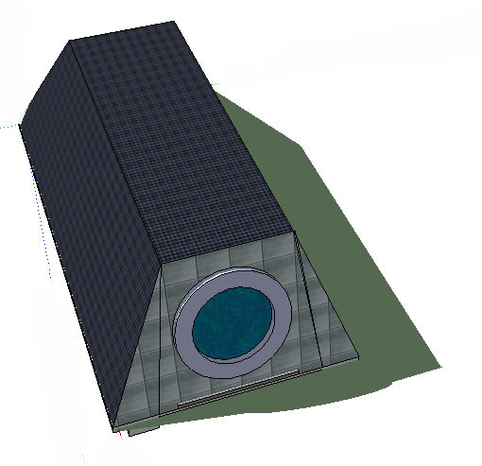 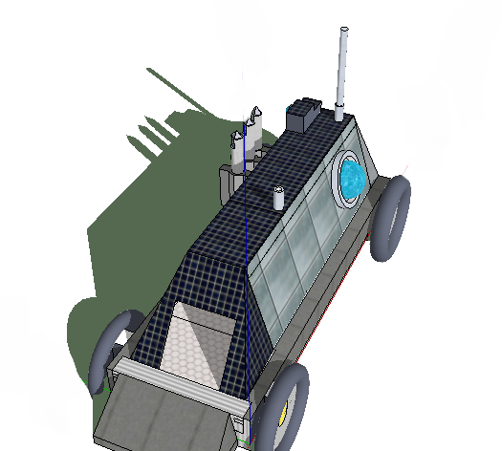

The above are the chambers and the rover used in hexagon chambers are designed to carry both human and the rover into lunar surface. Hence classifying the chambers into 2 types Green and Red.

The green chamber is designed for human survival fit with all the essentials required

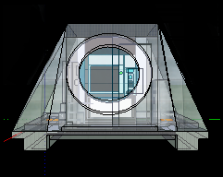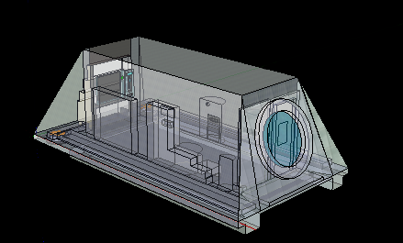

The chambers can fit in the rovers easily the inner chamber is exposed to the outer surface and then after the rover is out the room is oxidized and helps the chambers to support the life on board.

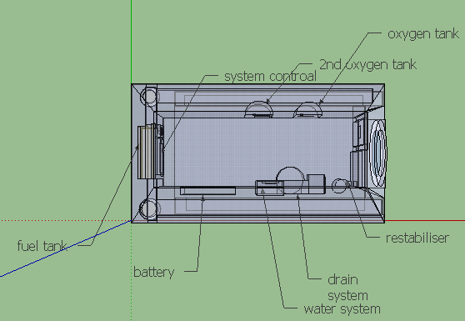

The above is the internal diagram of all life support system for chambers and they are also built to support the rovers the rovers as moved out of the chambers they will be going to be completely restabiliser for the human survival.

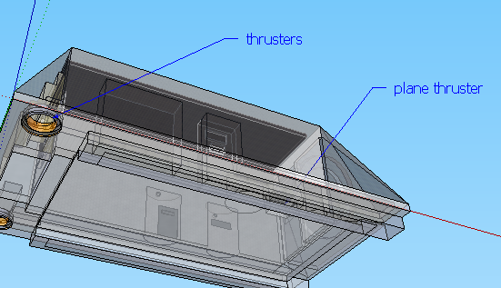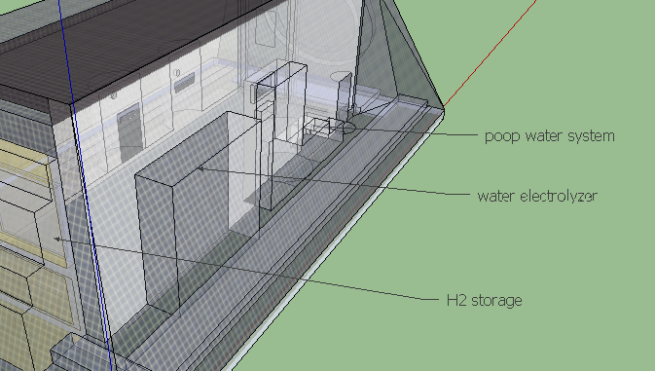

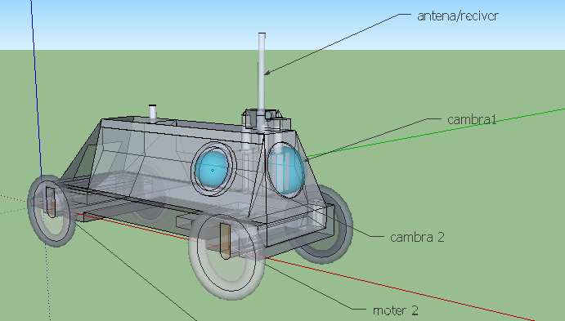

The rover has 3 camera which is 180/180 deg hence allowing a complete 360deg view of the lunar surface the antenna and receiver are designed to pop out of its holder the wheels are made by complex integrated mesh which electrically circuit which fills up the wheel and the elastic polymer helps the wheel to be much lighter stronger and reusable.

The driller and spot missile system are the best way for the transporting of lunar materials to sat1 and as the whole load completion the sat 1 makes an approach for the earth orbit and hence departing materials to ISS or use high level drop system which makes a smooth landing on earth surface. The lithium ion battery is used for high effect on the system to run for a longer time and is much better than other resources

The high end motor is designed to have more efficiency than other linked chained motor hence a 4 motor system is used in the rover hence more weight is added allowing it to have more ground pull.

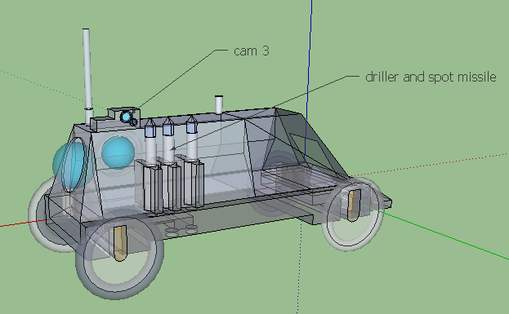

### Part 4: sat1

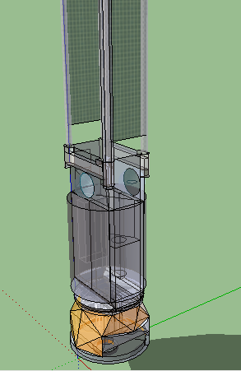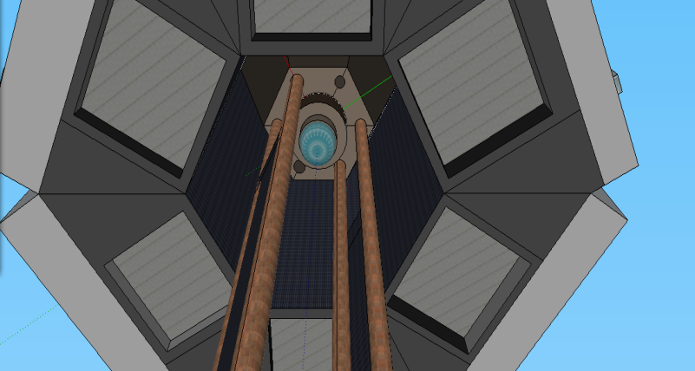

The solar panel is connected to the controller and as it is removed from the controller as it departs to make it to the lunar surface the two chambers move out making path for the solar panels linking the controller move out and the hexagon is on descent to the lunar surface. The fuel tank will be emptied as it makes space for the sub missile system to lock on to the sat1 and hence help them to bring the sample back to earth. The sat1 is designed especially for orbiter path around the moon and to receive the sub missiles shot from the rovers from the lunar surface. And after receiving all the sub missiles the sat1 makes a path back to earth. The main thrusters are extremely powerful and edge support system which would allow it to detach from the fuel tank of the sat1 and allow the sub missile to be capture easily the main thruster has additional fuel system to make it back to the earth orbit. The sat1 also uses laser communication.

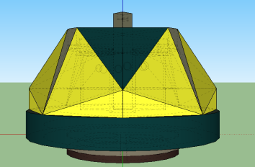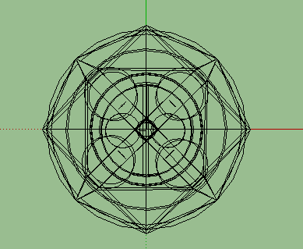 //Main thruster and its frame work.